**Practical File**

**COMPUTER GRAPHICS**

**Paper Code: CEC012**



**Bachelor of engineering**

**(2016-2020)**

**Computer Engineering**

**Submitted by:**

Geetanshu Gupta

2016UCO1671

COE-3

Semester IV

**DIVISION OF COMPUTER SCIENCE ENGINEERING**

**NETAJI SUBHAS INSTITUTE OF TECHNOLOGY, DWARKA**

**INDEX**

1. **Line drawing using DDA approach**
2. **Line drawing using midpoint approach**
3. **Drawing line using bresenham approach**
4. **Circle drawing using first order differential approach (mid-point approach)**
5. **Circle drawing using Bresenham approach**
6. **Pattern**
7. **Ellipse drawing using Bresenham approach**
8. **Line Clipping using Cyrus-Becker algorithm**
9. **Line clipping using Cohen-Sutherland approach**
10. **Polygon clipping via Sutherland-Hodgeman algortithm**
11. **Polygon clipping via Weiler Atherton algorithm**
12. **Polygon filling through Scanline approach**
13. **Demonstrating 3D transformations**
14. **Demonstrating the isometric view of a cube**
15. **Hidden surface elimination using back face detection**
16. **Drawing our name using hermite curve**
17. **Demonstrating the dimetric view of a cube**
18. **Line drawing using DDA approach** #include <graphics.h>

#include <math.h>

#include <iostream>

using namespace std;

void line_dda(int x1, int y1, int x2, int y2)

{

int dx = x2 - x1;

int dy = y2 - y1;

int steps = (abs(dx) > abs(dy)) ? abs(dx) : abs(dy);

float x = x1, y = y1;

float xinc = dx / (float)steps;

float yinc = dy / (float)steps;

for (int i = 0; i <= steps; ++i) {

putpixel(round(x), round(y), WHITE);

x += xinc;

y += yinc;

}

}

int main()

{

initwindow(800, 500);

int x1, y1, x2, y2;

cout << "Enter the x and y coordinates of the first point: ";

cin >> x1 >> y1;

cout << "Enter the x and y coordinates of the second point: ";

cin >> x2 >> y2;

line_dda(x1, y1, x2, y2);

getch();

return 0;

}

**OUTPUT:**

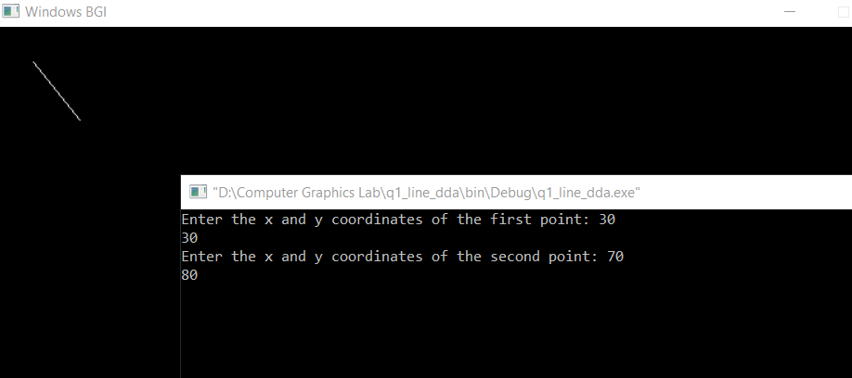

1. **Line drawing using midpoint approach**

#include <graphics.h>

#include <iostream>

using namespace std;

//for drawing line using mid-point algorithm which handles all the cases

void line_mpt (int x1, int y1, int x2, int y2, int color = WHITE)

{

int dx = abs(x2 - x1), dy = abs(y2 - y1), xsign, ysign;

bool compare;

if (abs (x2 - x1) > abs (y2 - y1)) { //major moment in x

if ((x2 - x1) * (y2 - y1) > 0) { //slope is +ve: mx - y + c = 0

xsign = -1, ysign = 1, compare = 1;

if (x1 > x2) {

swap(x1, x2); swap(y1, y2);

}

}

else { //slope is -ve: y + mx - c = 0

xsign = 1, ysign = -1, compare = 0;

if (x1 < x2) {

swap(x1, x2); swap(y1, y2);

}

}

int x = x1, y = y1;

int del = (dy * ysign) + (dx * xsign) / 2;

putpixel(x, y, color);

while (x != x2) {

x -= xsign;

if ((compare ? del < 0 : del > 0)) {

del += (dy * ysign);

}

else {

del += ((dy * ysign) + (dx * xsign));

y++;

}

putpixel(x, y, color);

}

}

else { //major moment in y

if ((x2 - x1) * (y2 - y1) > 0) { //slope is +ve: mx - y + c = 0

xsign = -1, ysign = 1, compare = 1;

if (x1 > x2) {

swap(x1, x2); swap(y1, y2);

}

}

else { //slope is -ve: y + mx - c = 0

xsign = 1, ysign = -1, compare = 0;

if (x1 < x2) {

swap(x1, x2); swap(y1, y2);

}

}

int x = x1, y = y1;

int del = (dx * xsign) + (dy * ysign) / 2;

putpixel(x, y, color);

while (y != y2) {

y ++;

if ((compare ? del > 0 : del < 0)) {

del += (dx * xsign);

}

else {

del += ((dx * xsign) + (dy * ysign));

x -= xsign;

}

putpixel(x, y, color);

}

}

}

int main()

{

initwindow(800, 500);

int x1, y1, x2, y2;

cout << "Enter the x and y coordinates of the first point: ";

cin >> x1 >> y1;

cout << "Enter the x and y coordinates of the second point: ";

cin >> x2 >> y2;

line_mpt(x1, y1, x2, y2);

getch();

return 0;

}

**OUTPUT:**

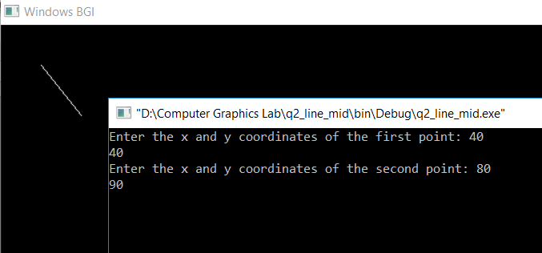

1. **Drawing line using bresenham approach**

#include <graphics.h>

#include <iostream>

using namespace std;

void myline (int x1, int y1, int x2, int y2)

{

int dx = x2 - x1;

int dy = y2 - y1;

if (dy == 0) {

while (x1 - x2) {

putpixel (x1, y1, WHITE);

if (dx > 0)

x1++;

else

x1--;

}

}

else if (dx == 0) {

while (y1 - y2) {

putpixel (x1, y1, WHITE);

if (dy > 0)

y1++;

else

y1--;

}

}

else if (abs(dy) <= abs(dx)) {

putpixel (x1, y1, WHITE);

int d = 2 * abs(dy) - abs(dx);

while (x1 - x2) {

if (d <= 0) {

d += 2 * (abs(dy));

}

else {

d += 2 * (abs(dy) - abs(dx));

if(dy > 0)

y1++;

else

y1--;

}

if (dx > 0)

x1++;

else

x1--;

putpixel(x1, y1, WHITE);

}

}

else if(abs(dx) < abs(dy)){

putpixel(x1, y1, WHITE);

int d = abs(dy) - 2 * abs(dx);

while (y1 - y2) {

if (d > 0) {

d += 2 * (-abs(dx));

}

else {

d += 2 * (abs(dy) - abs(dx));

if (dx > 0)

x1++;

else

x1--;

}

if(dy > 0)

y1++;

else

y1--;

putpixel(x1, y1, WHITE);

}

}

}

int main()

{

initwindow(800, 500);

int x1, y1, x2, y2;

cout << "Enter the x and y coordinates of the first point: ";

cin >> x1 >> y1;

cout << "Enter the x and y coordinates of the second point: ";

cin >> x2 >> y2;

myline(x1, y1, x2, y2);

getch();

return 0;

}

**OUTPUT:**

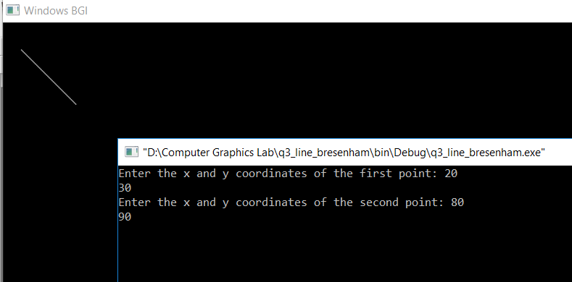

1. **Circle drawing using first order differential approach (mid point approach)**

#include <iostream>

#include <graphics.h>

using namespace std;

//for plotting 8 different points of circle using 8-symmetry

void pixel(int xc,int yc,int x,int y, int color)

{

putpixel(xc + x, yc + y, color);

putpixel(xc + y, yc + x, color);

putpixel(xc - y, yc + x, color);

putpixel(xc - x, yc + y, color);

putpixel(xc - x, yc - y, color);

putpixel(xc - y, yc - x, color);

putpixel(xc + y, yc - x, color);

putpixel(xc + x, yc - y, color);

}

void circle_mpt(int xc, int yc, int r, int color = WHITE)

{

int x = 0, y = r, d = 1 - r;

pixel(xc, yc, x, y, color);

while (x < y)

{

if (d < 0)

{

x++;

d += (2 * x) + 3;

}

else

{

x++;

y--;

d += 2 * (x - y) + 5;

}

pixel(xc, yc, x, y, color);

}

}

int main()

{

initwindow(800, 500);

int cx, cy, r;

cout << "Enter the x and y coordinate of the centre of the circle: ";

cin >> cx >> cy;

cout << "Enter the radius of the circle: ";

cin >> r;

circle_mpt(cx, cy, r);

getch();

return 0;

}

**OUTPUT:**

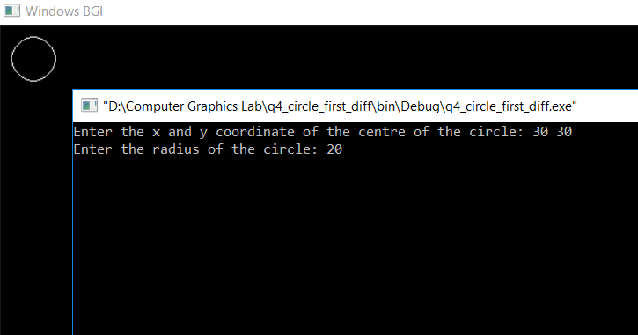

1. **Circle drawing using Bresenham approach**

#include <graphics.h>

#include <iostream>

using namespace std;

void drawCircle(int cx, int cy, int x, int y)

{

putpixel(cx + x, cy + y, WHITE);

putpixel(cx - x, cy + y, WHITE);

putpixel(cx + x, cy - y, WHITE);

putpixel(cx - x, cy - y, WHITE);

putpixel(cx + y, cy + x, WHITE);

putpixel(cx + y, cy - x, WHITE);

putpixel(cx - y, cy - x, WHITE);

putpixel(cx - y, cy + x, WHITE);

}

void mycircle(int cx, int cy, int r)

{

int x = 0, y = r, d = 3 - 2 * r;

drawCircle(cx, cy, x, y);

while (x <= y) {

if (d <= 0) {

d += (4 * x + 6);

}

else {

d += (4 * (x - y) + 10);

y--;

}

x++;

drawCircle(cx, cy, x, y);

}

}

int main()

{

initwindow(800, 500);

int cx, cy, r;

cout << "Enter the x and y coordinate of the center of the circle: ";

cin >> cx >> cy;

cout << "Enter the radius of the circle: ";

cin >> r;

mycircle(cx, cy, r);

getch();

return 0;

}

**OUTPUT:**

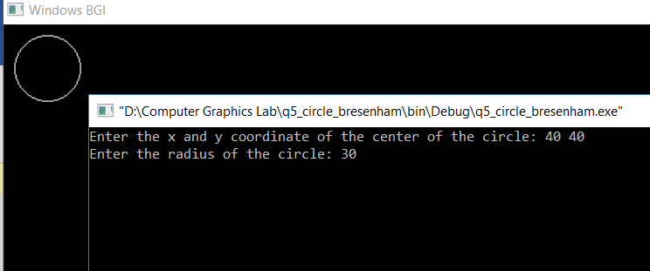

1. **Pattern**

#include <iostream>

#include<graphics.h>

#include<conio.h>

#include<math.h>

using namespace std;

void putting_pixel(int a0, int a1, int c1, int x_pivot, int y_pivot, int angle)

{

int x_shifted = a0 - x_pivot;

int y_shifted = a1 - y_pivot;

a0 = x_pivot + (x_shifted*cos(angle) - y_shifted*sin(angle));

a1 = y_pivot + (x_shifted*sin(angle) + y_shifted*cos(angle));

putpixel(a0, a1, c1);

}

void DrawCircle ( int cen_x , int cen_y , int Rad , int clr , float ang , int part)

{

int X , Y , r ,d ;

r = Rad;

X = 0 ;

Y = r ;

d = 1 - r;

ang = ang * (3.14/180) ;

putting_pixel(X + 320 , Y + 240 , WHITE,320,240,ang);

while ( X <= Y )

{

if ( d < 0 )

{

d += 2*X + 3;

}

else

{

d += 2*(X-Y)+5;

Y--;

}

X++;

// putpixel( x+320+cen_x , -y+240+cen_y , clr ) ;

// putpixel( y+320+cen_x , -x+240+cen_y , clr ) ;

// putpixel( y+320+cen_x , x+240+cen_y , clr ) ;

// putpixel( x+320+cen_x , y+240+cen_y , clr ) ;

// putpixel( -x+320+cen_x , y+240+cen_y , clr ) ;

// putpixel( -y+320+cen_x , x+240+cen_y , clr ) ;

// putpixel( -y+320+cen_x , -x+240+cen_y , clr ) ;

// putpixel( -x+320+cen_x , -y+240+cen_y , clr ) ;

float x,y;

//float x_,y_;

// x_ = 320 + cen_x ;

// y_ = +240 + cen_y ;// X*sin(ang) + Y*cos(ang);

//x = X*cos(ang) + Y*sin(ang);

//y = -X*sin(ang) + Y*cos(ang);

x = X ;

y = Y;

if (part==1)

{

putting_pixel( x+320 + cen_x , -y+240 + cen_y , clr ,320 , 240 , ang) ;

putting_pixel( y+320 + cen_x , -x+240 + cen_y , clr ,320 , 240 ,ang) ;

putting_pixel( y+320 + cen_x , x+240 + cen_y , clr, 320 , 240 , ang ) ;

putting_pixel( x+320 + cen_x , y+240 + cen_y , clr , 320 , 240 , ang) ;

}

else if(part==2)

{

putting_pixel( y+320 + cen_x , x+240 + cen_y , clr ,320 , 240 , ang) ;

putting_pixel( x+320 + cen_x , y+240 + cen_y , clr ,320 , 240 , ang) ;

putting_pixel( -x+320 + cen_x , y+240 + cen_y , clr ,320 , 240 , ang) ;

putting_pixel( -y+320 + cen_x , x+240 + cen_y , clr ,320 , 240 , ang) ;

}

else if (part==3)

{

putting_pixel( -x+320 + cen_x , y+240 + cen_y , clr ,320 , 240 , ang) ;

putting_pixel( -y+320 + cen_x , x+240 + cen_y , clr ,320 , 240 , ang) ;

putting_pixel( -y+320 + cen_x , -x+240 + cen_y , clr ,320 , 240 , ang) ;

putting_pixel( -x+320 + cen_x , -y+240 + cen_y , clr ,320 , 240 , ang) ;

}

else if (part==4)

{

putting_pixel( x+320 + cen_x , -y +240 + cen_y , clr ,320 , 240 , ang) ;

putting_pixel( y+320 + cen_x , -x+240 + cen_y , clr ,320 , 240 , ang) ;

putting_pixel( -y+320 + cen_x , -x+240 + cen_y , clr ,320 , 240 , ang) ;

putting_pixel( -x+320 + cen_x , -y+240 + cen_y , clr ,320 , 240 , ang) ;

}

}

}

int main()

{

cout << "Hello world!" << endl;

int gd = DETECT,gm;//left=100,top=100,right=200,bottom=200,x= 300,y=150,radius=50;

initgraph(&gd, &gm, "C:\\TC\\BGI");

int angle = 0 ;

DrawCircle(0,-40,40,0xffffff,angle,3);

DrawCircle(0,-60,20,0xffffff,angle,1);

DrawCircle(0,-20,20,0xffffff,angle,3);

DrawCircle(0,40,40,0xffffff,angle,1);

DrawCircle(0,60,20,0xffffff,angle,3);

DrawCircle(0,20,20,0xffffff,angle,1);

DrawCircle(-40,0,40,0xffffff,angle,2);

DrawCircle(-60,0,20,0xffffff,angle,4);

DrawCircle(-20,0,20,0xffffff,angle,2);

DrawCircle(40,0,40,0xffffff,angle,4);

DrawCircle(60,0,20,0xffffff,angle,2);

DrawCircle(20,0,20,0xffffff,angle,4);

//angle--;

getch();

closegraph();

return 0;

}

**OUTPUT:**

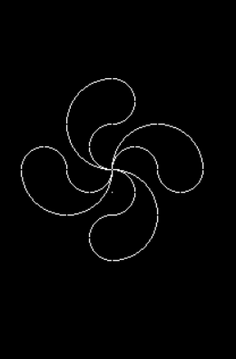

1. **Ellipse drawing using Bresenham approach.**

#include <iostream>

#include <graphics.h>

using namespace std;

void drawEllipse(int cx, int cy,int x, int y)

{

putpixel(cx + x, cy - y, WHITE);

putpixel(cx + x, cy + y, WHITE);

putpixel(cx - x, cy - y, WHITE);

putpixel(cx - x, cy + y, WHITE);

}

void myellipse(int cx, int cy, int a, int b)

{

int x = 0, y = b;

int d = 2 * b * b + a * a - 2 * a * a * b;

drawEllipse(cx, cy, x, y);

while (a * a * y > x * b * b) {

if (d > 0) {

d += (2 * b * b * (2 * x + 3) - 4 * a * a * (y - 1));

y--;

}

else {

d += (2 * b * b * (2 * x + 3));

}

x++;

drawEllipse(cx, cy, x, y);

}

d = 2 * b * b * x * x + b * b + 2 * b * b * x + 2 * a * a * y * y + 2 * a * a - 4 * a * a * y - 2 * a * a * b * b;

while (y >= 0) {

if (d < 0) {

d += (4 * b * b * (x + 1) - 2 * a * a * (2 * y - 3));

x++;

}

else {

d += 2 * a * a * (3 - 2 * y);

}

y--;

drawEllipse(cx, cy, x, y);

}

}

int main()

{

initwindow(800, 500);

int a, b, cx, cy;

cout << "Enter the center of ellipse: ";

cin >> cx >> cy;

cout << "Enter the values of a and b for ellipse: ";

cin >> a >> b;

myellipse(cx, cy, a, b);

getch();

return 0;

}

**OUTPUT:**

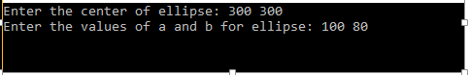

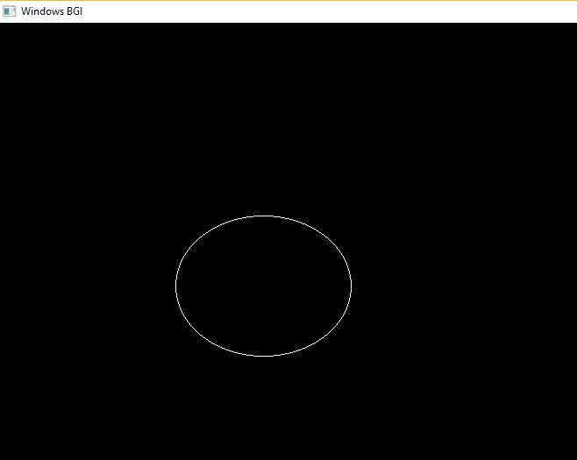

1. **Line clipping using Cyrus-Becker algorithm**

#include <iostream>

#include <graphics.h>

#include <stdlib.h>

#include <stdio.h>

#include <conio.h>

#include <math.h>

using namespace std;

int main()

{

int gdriver = DETECT, gmode, errorcode;

initgraph(&gdriver, &gmode, "C:/TURBOC3/BGI");

errorcode = graphresult();

if (errorcode != grOk)

{

printf("Graphics error: %s\n", grapherrormsg(errorcode));

printf("Press any key to halt:");

getch();

exit(1);

}

int wind[6][2]= {{30,150},{25,60},{80,70},{30,50},{100,40},{10,10}};

int point[2][2]= {{10,120},{80,-20}};

int inters[6][2];

int i;

int edge[6][2];

for(i=0; i<5; i++)

{

edge[i][0]=wind[i+1][0]-wind[i][0];

edge[i][1]=wind[i+1][1]-wind[i][1];

}

edge[5][0]=wind[0][0]-wind[5][0];

edge[5][1]=wind[0][1]-wind[5][1];

int nor[6][2];

for( i=0; i<6; i++)

{

nor[i][0]=-edge[i][1];

nor[i][1]=edge[i][0];

}

float num[6],den[6],t[6];

for( i=0; i<6; i++)

{

float numx=(point[0][0]-wind[i][0])*(nor[i][0]);

float numy=(point[0][1]-wind[i][1])*(nor[i][1]);

num[i]=numx+numy;

float denx=((nor[i][0])*(point[1][0]-point[0][0]));

float deny=((nor[i][1])*(point[1][1]-point[0][1]));

den[i]=-(denx+deny);

t[i]=num[i]/den[i];

}

setcolor(RED);

for(i=0; i<5; i++)

{

line(360+wind[i][0],240-wind[i][1],360+wind[i+1][0],240-wind[i+1][1]);

}

line(360+wind[5][0],240-wind[5][1],360+wind[0][0],240-wind[0][1]);

for(i=0; i<6; i++)

{

inters[i][0]=point[0][0]+(point[1][0]-point[0][0])*t[i];

inters[i][1]=point[0][1]+(point[1][1]-point[0][1])*t[i];

}

setcolor(YELLOW);

line(360+inters[1][0],240-inters[1][1],360+inters[2][0],240-inters[2][1]);

line(360+inters[3][0],240-inters[3][1],360+inters[4][0],240-inters[4][1]);

line(360+inters[5][0],240-inters[5][1],360+inters[0][0],240-inters[0][1]);

setcolor(CYAN);

line(360+point[0][0],240-point[0][1],360+inters[5][0],240-inters[5][1]);

line(360+inters[0][0],240-inters[0][1],360+inters[1][0],240-inters[1][1]);

line(360+inters[2][0],240-inters[2][1],360+inters[3][0],240-inters[3][1]);

line(360+point[1][0],240-point[1][1],360+inters[4][0],240-inters[4][1]);

getch();

closegraph();

return 0;

}

**OUTPUT:**

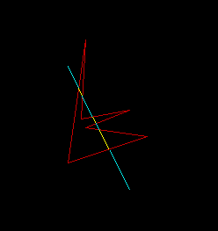

1. **Line clipping using Cohen-Sutherland approach**

#include <iostream>

#include <graphics.h>

#define LEFT 1

#define BOTTOM 2

#define RIGHT 4

#define TOP 8

using namespace std;

struct point

{

float x,y;

};

float xmin,ymin,xmax,ymax;

int code(point a)

{

int reg=0;

if(a.x<xmin)

reg=reg|LEFT;

if(a.x>xmax)

reg=reg|RIGHT;

if(a.y<ymin)

reg=reg|BOTTOM;

if(a.y>ymax)

reg=reg|TOP;

return reg;

}

int main()

{

cout << "Enter dimensions of rectangular window: ";

cin >> xmin >> ymin >> xmax >> ymax;

cout << "Enter the end points: ";

point ini,fin;

cin >> ini.x >> ini.y >> fin.x >> fin.y;

float m=(fin.y-ini.y)/(fin.x-ini.x);

int gd=DETECT,gm;

initgraph(&gd,&gm,"C:/TC/BGI");

setcolor(RED);

line(xmin+320,240-ymin,320+xmax,240-ymin);

line(xmax+320,240-ymin,320+xmax,240-ymax);

line(320+xmax,240-ymax,320+xmin,240-ymax);

line(320+xmin,240-ymax,320+xmin,240-ymin);

setcolor(WHITE);

while (1) {

int r1=code(ini);

int r2=code(fin);

if ((r1&r2)!=0) {

break;

}

if((r1|r2)==0) { //visible

line(ini.x+320,240-ini.y,320+fin.x,240-fin.y);

break;

}

//partially

if(r1==0) { //ensuring r1 always has non centre coordinate

int temp=r1;

r1=r2;

r2=temp;

point t=ini;

ini=fin;

fin=t;

}

if(r1&LEFT) {

float ynew=m*(xmin-ini.x)+ini.y;

ini.y=ynew;

ini.x=xmin;

}

else if(r1&RIGHT) {

float ynew=m*(xmax-ini.x)+ini.y;

ini.y=ynew;

ini.x=xmax;

}

else if(r1&BOTTOM) {

float xnew=(1/m)*(ymin-ini.y)+ini.x;

ini.y=ymin;

ini.x=xnew;

}

else if(r1&TOP) {

float xnew=(1/m)*(ymax-ini.y)+ini.x;

ini.y=ymax;

ini.x=xnew;

}

}

getch();

return 0;

}

**OUTPUT:**

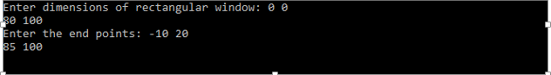

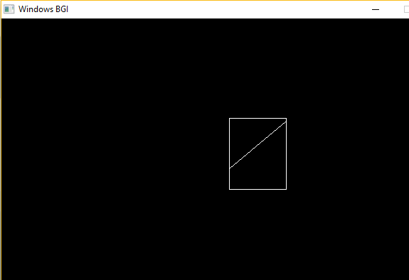

1. **Polygon clipping via Sutherland-Hodgeman algorithm**

#include <iostream>

#include <graphics.h>

using namespace std;

const int MAX_POINTS = 20;

int x_intersect(int x1, int y1, int x2, int y2, int x3, int y3, int x4, int y4)

{

int num = (x1*y2 - y1*x2) * (x3-x4) - (x1-x2) * (x3*y4 - y3*x4);

int den = (x1-x2) * (y3-y4) - (y1-y2) * (x3-x4);

return num/den;

}

int y_intersect(int x1, int y1, int x2, int y2, int x3, int y3, int x4, int y4)

{

int num = (x1*y2 - y1*x2) * (y3-y4) - (y1-y2) * (x3*y4 - y3*x4);

int den = (x1-x2) * (y3-y4) - (y1-y2) * (x3-x4);

return num/den;

}

void clip(int poly_points[][2], int &poly_size, int x1, int y1, int x2, int y2)

{

int new_points[MAX_POINTS][2], new_poly_size = 0;

for (int i = 0; i < poly_size; i++) {

int k = (i+1) % poly_size;

int ix = poly_points[i][0], iy = poly_points[i][1];

int kx = poly_points[k][0], ky = poly_points[k][1];

int i_pos = (x2-x1) * (iy-y1) - (y2-y1) * (ix-x1);

int k_pos = (x2-x1) * (ky-y1) - (y2-y1) * (kx-x1);

if (i_pos < 0 && k_pos < 0) {

new_points[new_poly_size][0] = kx;

new_points[new_poly_size][1] = ky;

new_poly_size++;

}

else if (i_pos >= 0 && k_pos < 0) {

new_points[new_poly_size][0] = x_intersect(x1, y1, x2, y2, ix, iy, kx, ky);

new_points[new_poly_size][1] = y_intersect(x1, y1, x2, y2, ix, iy, kx, ky);

new_poly_size++;

new_points[new_poly_size][0] = kx;

new_points[new_poly_size][1] = ky;

new_poly_size++;

}

else if (i_pos < 0 && k_pos >= 0) {

new_points[new_poly_size][0] = x_intersect(x1, y1, x2, y2, ix, iy, kx, ky);

new_points[new_poly_size][1] = y_intersect(x1, y1, x2, y2, ix, iy, kx, ky);

new_poly_size++;

}

else {

//No points are added

}

}

poly_size = new_poly_size;

for (int i = 0; i < poly_size; i++) {

poly_points[i][0] = new_points[i][0];

poly_points[i][1] = new_points[i][1];

}

}

void suthHodgClip(int poly_points[][2], int poly_size, int clipper_points[][2], int clipper_size)

{

for (int i=0; i<clipper_size; i++) {

int k = (i+1) % clipper_size;

clip(poly_points, poly_size, clipper_points[i][0], clipper_points[i][1], clipper_points[k][0], clipper_points[k][1]);

}

setlinestyle(0, 1, 3);

setcolor(2);

for (int i=0; i < poly_size; i++) {

line(poly_points[i][0], poly_points[i][1], poly_points[(i+1)%poly_size][0], poly_points[(i+1)%poly_size][1]);

}

}

int main()

{

initwindow(800, 500);

int poly_size = 3;

setlinestyle(3, 1, 1);

int poly_points[20][2] = {{100,150}, {200,250}, {300,200}};

for (int i=0; i < poly_size; i++) {

line(poly_points[i][0], poly_points[i][1], poly_points[(i+1)%poly_size][0], poly_points[(i+1)%poly_size][1]);

}

setcolor(14);

int clipper_size = 3;

int clipper_points[][2] = {{100,300}, {300,300}, {200,100}};

for (int i=0; i < clipper_size; i++) {

line(clipper_points[i][0], clipper_points[i][1], clipper_points[(i+1)%clipper_size][0], clipper_points[(i+1)%clipper_size][1]);

}

suthHodgClip(poly_points, poly_size, clipper_points, clipper_size);

getch();

return 0;

}

**OUTPUT:**

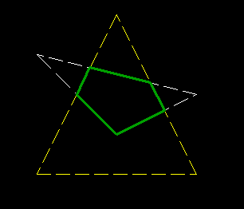

1. **Polygon clipping via Weiler Atherton algorithm**

#include <bits/stdc++.h>

#include <graphics.h>

using namespace std;

float sdx[15],sdy[15];

int i,w=0,h;

void sort(float sdy[],int h)

{

float temp;

for(int j=0;j<=h-1;j++)

{

for(i=0;i<h-1-j;i++)

{

if(sdy[i]>sdy[i+1])

{

temp=sdy[i];

sdy[i]=sdy[i+1];

sdy[i+1]=temp;

}

}

}

}

struct points

{

float x;

float y;

float io;

float vis;

};

struct points z[20];

int main()

{

initwindow(640, 480);

int n,m,s;

float px[15]={0};

float py[15]={0};

float pdx[15],pdy[10];

float outx[15]={0};

float outy[15]={0};

float xmin,ymin,xmax,ymax;

cout<<"\nEnter xmin,ymin,xmax,ymax: ";

cin>>xmin>>ymin>>xmax>>ymax;

setcolor(YELLOW);

rectangle(320+xmin,240-ymax,320+xmax,240-ymin);

cout<<"\nEnter the no. of vertices (n): ";

cin>>n;

cout<<"\nEnter the x coordinate of all vertices: ";

for(m=0;m<n;m++)

{

cin>>px[m];

}

cout<<"\nEnter the y coordinate of all vertices: ";

cout<<"\nEnter the y coordinate of all vertices: ";

for(m=0;m<n;m++)

{

cin>>py[m];

}

setcolor(GREEN);

px[n]=px[0];py[n]=py[0];

for(s=0;s<n;s++)

{

line(320+px[s],240-py[s],320+px[s+1],240-py[s+1]);

}

getch();

cleardevice();

getch();

px[n]=px[0];

py[n]=py[0]; int l=0;

for(m=0;m<n;m++)

{

if(px[m]>=xmin && px[m+1]<=xmin)

{

pdx[m]=xmin;

pdy[m]=py[m]+((py[m+1]-py[m])/(px[m+1]-px[m]))*(xmin-px[m]);

outx[l]=pdx[m];outy[l]=pdy[m];

z[l].io=1;

l++;

}

if(px[m]>=xmin && px[m+1]>=xmin)

{

outx[l]=px[m+1];outy[l]=py[m+1];

z[l].io=0;

l++;

}

if(px[m]<=xmin && px[m+1]>=xmin)

{

pdx[m]=xmin;

pdy[m]=py[m]+((py[m+1]-py[m])/(px[m+1]-px[m]))*(xmin-px[m]);

outx[l]=pdx[m];outy[l]=pdy[m];

z[l].io=0;

l++;

outx[l]=px[m+1];outy[l]=py[m+1];

z[l].io=0;

l++;

}

}

outx[l]=outx[0];outy[l]=outy[0];

setcolor(YELLOW);

rectangle(320+xmin,240-ymax,320+xmax,240-ymin);

setcolor(GREEN);

for(i=0;i<l;i++)

{

if(outx[i]==xmin)

{

sdx[w]=outx[i];

sdy[w]=outy[i];

w++;

}

}

sort(sdy,w);

outx[l]=outx[0];outy[l]=outy[0];

for(i=0;i<=l;i++)

{

z[i].x=outx[i];

z[i].y=outy[i];

z[i].vis=0;

}

s=0;

for(m=0;m<=l-1;m++)

{

outx[l]=outx[0];outy[l]=outy[0];

sdx[w+1]=sdx[0];sdy[w+1]=sdy[0];

if(z[s].io==0)

{

line(320+outx[s],240-outy[s],320+outx[s+1],240-outy[s+1]);

z[s].vis=1;

z[s+l].vis=1;

}

else if(z[s].io==1)

{

for(i=0;i<=w;i++)

{

if(sdy[i]==outy[s])

{

line(320+sdx[i],240-sdy[i],320+sdx[i+1],240-sdy[i+1]);

z[s].vis=1;

z[s+l].vis=1;

break;

}

}

for(int j=0;j<l;j++)

{

if(sdy[i+1]==z[j].y)

{

s=j;

line(320+outx[s],240-outy[s],320+outx[s+1],240-outy[s+1]);

z[s].vis=1;

z[s+l].vis=1;

break;

}

}

}

if(s<=l-1)

s++;

else

s=0;

if(s==l)

s=0;

int p=s;

while(z[s].vis == 1)

{

s++;

if(s==p+l)

{

break;

}

}

}

getch();

return 0;

}

**OUTPUT:**

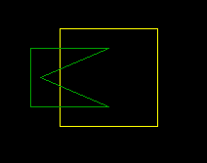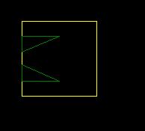

1. **Polygon filling through Scanline approach**

#include <stdio.h>

#include <graphics.h>

#include <iostream>

using namespace std;

int main()

{

int n, i, j, k, dy, dx;

int x, y, temp;

int xv[20], yv[20], xi[20];

float slope[20];

cout << "Enter the no. of edges of polygon : ";

cin >> n;

cout << "Enter the co-ordinates of polygon :\n";

for (i = 0; i < n; i++) {

printf("\tX%d Y%d : ",i,i);

scanf("%d %d",&xv[i],&yv[i]);

}

xv[n]=xv[0];

yv[n]=yv[0];

initwindow(800, 500);

/* draw polygon */

for (i = 0; i < n; i++) {

line(xv[i],yv[i],xv[i+1],yv[i+1]);

delay(50);

}

for (i = 0; i < n; i++) {

dy = yv[i+1] - yv[i];

dx = xv[i+1] - xv[i];

if(dy==0)

slope[i]=1.0;

if(dx==0)

slope[i]=0.0;

if ((dy != 0) && (dx != 0)) {/*- calculate inverse slope -*/

slope[i] = (float) dx / dy;

}

}

for(y = 0; y < 480; y++) {

k = 0;

for (i=0;i<n;i++) {

if (((yv[i] <= y) && (yv[i+1] > y)) || ((yv[i] > y) && (yv[i+1] <= y))) {

xi[k] = (int)(xv[i] + slope[i] * (y - yv[i]));

k++;

}

}

for(j = 0; j < k - 1; j++) {/*- Arrange x-intersections in order -*/

for(i = 0; i < k - 1; i++) {

if(xi[i] > xi[i+1]) {

temp =xi[i];

xi[i] = xi[i+1];

xi[i+1] = temp;

}

}

setcolor(4);

for(i = 0; i < k; i += 2) {

line(xi[i], y, xi[i+1] + 1, y);

delay(10);

}

}

}

getch();

return 0;

}

**OUTPUT:**

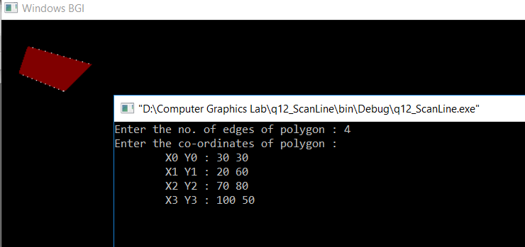

1. **Demonstrating 3D transformations**

#include<graphics.h>

#include<bits/stdc++.h>

using namespace std;

int main()

{

initwindow(700, 480);

int p[4][8] = { {-40,40,40,-40,-20,20,20,-20},

{40,40,-40,-40,20,20,-20,-20},

{0,0,0,0,60,60,60,60},

{1,1,1,1,1,1,1,1} };

float pr[4][8];

int i, j, k, page = 0;

float q = 0.0, sum = 0, d = 0;

settextstyle(8, HORIZ_DIR, 1);

while(1)

{

setactivepage(page); setvisualpage(1 - page); cleardevice();

q=((d*(22/7.0))/180.0);

float rotatez[4][4]={ {cos(q), -sin(q), 0, 0},

{sin(q), cos(q), 0, 0},

{0, 0, 1, 0},

{0, 0, 0, 1} };

for (i = 0; i <= 3; i++) {

for (j = 0; j <= 8; j++) {

sum = 0;

for (k = 0; k <= 3; k++) {

sum += rotatez[i][k] * p[k][j];

}

pr[i][j] = sum;

}

}

//top view

outtextxy(68, 100, "Top View");

for(i=0;i<4;i++) {

line(115+pr[0][i],240-pr[1][i],115+pr[0][(i+1)%4],240-pr[1][(i+1)%4]);

line(115+pr[0][i+4],240-pr[1][i+4],115+pr[0][(i+1)%4+4],240-pr[1][(i+1)%4+4]);

line(115+pr[0][i],240-pr[1][i],115+pr[0][i+4],240-pr[1][i+4]);

}

line(230, 0, 230, getmaxy());

//front view

outtextxy(290, 100, "Front View");

for(i=0;i<4;i++) {

line(350+pr[0][i],265-pr[2][i],350+pr[0][(i+1)%4],265-pr[2][(i+1)%4]);

line(350+pr[0][i+4],265-pr[2][i+4],350+pr[0][(i+1)%4+4],265-pr[2][(i+1)%4+4]);

line(350+pr[0][i],265-pr[2][i],350+pr[0][i+4],265-pr[2][i+4]);

}

line(460, 0, 460, getmaxy());

//side view

outtextxy(535, 100, "Side View");

for(i=0;i<4;i++) {

line(550+pr[2][i],240-pr[1][i],550+pr[2][(i+1)%4],240-pr[1][(i+1)%4]);

line(550+pr[2][i+4],240-pr[1][i+4],550+pr[2][(i+1)%4+4],240-pr[1][(i+1)%4+4]);

line(550+pr[2][i],240-pr[1][i],550+pr[2][i+4],240-pr[1][i+4]);

}

page = 1 - page, d++;

delay(5);

}

getch();

return 0;

}

**OUTPUT:**

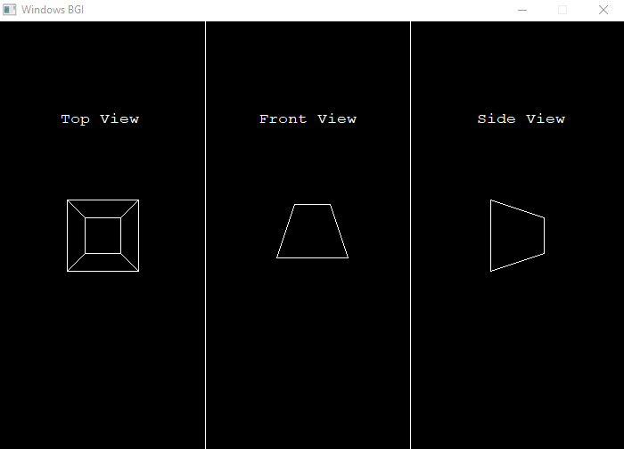

1. **Demonstrating the isometric view of a cube**

#include<iostream>

#include<graphics.h>

#include<conio.h>

#include<windows.h>

#include<cmath>

using namespace std;

void makecubeFront(float obj[8][4])

{

for(int i=0;i<4;i++){

line(210+obj[i][0],240-obj[i][1],210+obj[(i+1)%4][0],240-obj[(i+1)%4][1]);

line(210+obj[i+4][0],240-obj[i+4][1],210+obj[((i+1)%4)+4][0],240-obj[((i+1)%4)+4][1]);

line(210+obj[i][0],240-obj[i][1],210+obj[i+4][0],240-obj[i+4][1]);

}

}

void multiply(float obj[][4],float trans[4][4], int rows)

{

float mul[rows][4];

for(int i=0;i<rows;i++){

for(int j=0;j<4;j++){

float sum=0;

for(int k=0;k<4;k++){

sum=sum+(obj[i][k]*trans[k][j]);

}

mul[i][j]=sum;

}

}

for(int i=0;i<rows;i++){

for(int j=0;j<4;j++)

obj[i][j]=mul[i][j];

}

}

int main()

{

float pi=3.14159265;

float obj[8][4]={0,120,0,0,120,120,0,0,120,0,0,0,0,0,0,0,0,120,120,0,120,120,120,0,120,0,120,0,0,0,120,0};

int gd = DETECT,gm;

initgraph(&gd, &gm, "C:\\TC\\BGI");

//initwindow(1720,720);

// float isometric[4][4]={0.7071,0,-0.7071,0,-0.40825,0.8165,-0.40825,0,0.7071,0.40825,0.8165,0,0,0,0,1}; wrong matrix (actually transpose)

float isometric[4][4]={0.7071,-0.40825,0.7071,0,0,0.8165,0.40825,0,-0.7071,-0.40825,0.8165,0,0,0,0,1};

multiply(obj,isometric,8); ///If you want rotation wrt any axis, uncomment the code below

float rotx[4][4]={1,0,0,0,0,cos(pi/180),-1*sin(pi/180),0,0,sin(pi/180),cos(pi/180),0,0,0,0,1};

float roty[4][4]={cos(pi/180),0,sin(pi/180),0,0,1,0,0,-1*sin(pi/180),0,cos(pi/180),0,0,0,0,1};

float rotz[4][4]={cos(pi/180),-1*sin(pi/180),0,0,sin(pi/180),cos(pi/180),0,0,0,0,1,0,0,0,0,1};

for(int theta=0;theta<90;theta++){

multiply(obj,rotx,8);

setcolor(WHITE);

makecubeFront(obj);

Sleep(100);

setcolor(BLACK);

makecubeFront(obj);

}

for(int theta=0;theta<90;theta++){

multiply(obj,roty,8);

setcolor(WHITE);

makecubeFront(obj);

Sleep(100);

setcolor(BLACK);

makecubeFront(obj);

}

for(int theta=0;theta<90;theta++){

multiply(obj,rotz,8);

setcolor(WHITE);

makecubeFront(obj);

Sleep(100);

setcolor(BLACK);

makecubeFront(obj);

}

setcolor(WHITE);

makecubeFront(obj);

getch();

closegraph();

return 0;

}

**OUTPUT:**

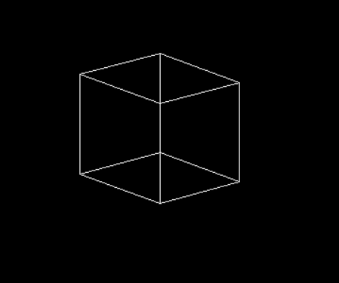

1. **Hidden surface elimination using back face detection.**

#include<math.h>

#include<graphics.h>

#define pi 3.14

float prism[4][8]= {{0, 80, 80, 0, 20, 60, 60, 20},

{80, 80, 0, 0, 60, 60, 20, 20},

{0, 0, 0, 0, -60, -60, -60, -60},

{1, 1, 1, 1, 1, 1, 1, 1} };

float dot(float n1[],float n2[])

{

int i;

float ans=0;

for(i=0; i<3; i++) {

ans+=(n1[i]*n2[i]);

}

return ans;

}

float mag(float n[])

{

return(sqrt(n[0]*n[0]+n[1]*n[1]+n[2]*n[2]));

}

void normal(float n[],int a,int b,int c,int s1,int s2)

{

int i;

float n1[3],n2[3],n3[3],v[3],cos;

for(i=0; i<3; i++) {

n1[i]=prism[i][a];

n2[i]=prism[i][b];

n3[i]=prism[i][c];

v[i]=prism[i][s1]-prism[i][s2];

}

n[0]=((n1[1]-n2[1])*(n2[2]-n3[2]))-((n1[2]-n2[2])*(n2[1]-n3[1]));

n[1]=((n1[2]-n2[2])*(n2[0]-n3[0]))-((n1[0]-n2[0])*(n2[2]-n3[2]));

n[2]=((n1[0]-n2[0])*(n2[1]-n3[1]))-((n1[1]-n2[1])*(n2[0]-n3[0]));

cos=dot(n,v)/(mag(n)*mag(v));

if(cos>0)

for(i=0; i<3; i++)

n[i]=n[i]*(-1);

}

void mp(float n[],int a,int b)

{

int i;

for(i=0; i<3; i++)

n[i]=(prism[i][a]+prism[i][b])/2;

n[2]-=32768;

}

void fline(int x0,int y0,int x1,int y1,int x2,int y2,int c1=15,int style=0)

{

setcolor(c1);

setlinestyle(style,1,1);

line(x0+x1,y0-y1,x0+x2,y0-y2);

setcolor(15);

setlinestyle(0,1,1);

}

void surface(int x0,int y0,int t,float prism[][8],int color[])

{

int i,j,style=0;

float n[3],n2[3];

if(t==0) { //ABCD

normal(n,0,1,2,4,0);

mp(n2,0,2);

if(dot(n,n2)>0)

style=3;

for(i=0; i<4; i++) {

j=i+1;

if(j==4)

j=0;

fline(x0,y0,prism[0][i],prism[1][i],prism[0][j],prism[1][j],color[t],style);

}

setfillstyle(SOLID_FILL,color[t]);

}

else if(t==1) { //EFGH

normal(n,4,5,6,0,4);

mp(n2,4,6);

if(dot(n,n2)>0)

style=3;

for(i=4; i<8; i++) {

j=i+1;

if(j==8)

j=4;

fline(x0,y0,prism[0][i],prism[1][i],prism[0][j],prism[1][j],color[t],style);

}

setfillstyle(SOLID_FILL,color[t]);

}

else if(t==2) { //GFBC

normal(n,6,5,1,4,5);

mp(n2,6,1);

if(dot(n,n2)>0)

style=3;

fline(x0,y0,prism[0][6],prism[1][6],prism[0][5],prism[1][5],color[t],style);//GF

fline(x0,y0,prism[0][5],prism[1][5],prism[0][1],prism[1][1],color[t],style); //FB

fline(x0,y0,prism[0][1],prism[1][1],prism[0][2],prism[1][2],color[t],style); //BC

fline(x0,y0,prism[0][2],prism[1][2],prism[0][6],prism[1][6],color[t],style); //CG

setfillstyle(SOLID_FILL,color[t]);

}

else if(t==3) {//GCDH

normal(n,6,2,3,5,6);

mp(n2,6,3);

if(dot(n,n2)>0)

style=3;

fline(x0,y0,prism[0][6],prism[1][6],prism[0][2],prism[1][2],color[t],style);//GC

fline(x0,y0,prism[0][2],prism[1][2],prism[0][3],prism[1][3],color[t],style);//CD

fline(x0,y0,prism[0][3],prism[1][3],prism[0][7],prism[1][7],color[t],style);//DH

fline(x0,y0,prism[0][7],prism[1][7],prism[0][6],prism[1][6],color[t],style);//HG

setfillstyle(SOLID_FILL,color[t]);

}

else if(t==4) { //AEFB

normal(n,4,5,1,6,5);

mp(n2,1,5);

if(dot(n,n2)>0)

style=3;

fline(x0,y0,prism[0][0],prism[1][0],prism[0][4],prism[1][4],color[t],style);//AE

fline(x0,y0,prism[0][4],prism[1][4],prism[0][5],prism[1][5],color[t],style);//EF

fline(x0,y0,prism[0][5],prism[1][5],prism[0][1],prism[1][1],color[t],style);//FB

fline(x0,y0,prism[0][1],prism[1][1],prism[0][0],prism[1][0],color[t],style);//BA

setfillstyle(SOLID_FILL,color[t]);

}

else if(t==5) { //EADH

normal(n,4,0,3,5,4);

mp(n2,4,3);

if(dot(n,n2)>0)

style=3;

fline(x0,y0,prism[0][4],prism[1][4],prism[0][0],prism[1][0],color[t],style);//EA

fline(x0,y0,prism[0][0],prism[1][0],prism[0][3],prism[1][3],color[t],style);//AD

fline(x0,y0,prism[0][3],prism[1][3],prism[0][7],prism[1][7],color[t],style);//DH

fline(x0,y0,prism[0][7],prism[1][7],prism[0][4],prism[1][4],color[t],style);//HE

setfillstyle(SOLID_FILL,color[t]);

}

}

void front(float prism[][8],int x0=320,int y0=240)

{

int i;

int color[6]= {15,15,15,15,15,15};

for(i=0; i<6; i++)

surface(x0,y0,i,prism,color);

}

int main()

{

initwindow(640,480);

front(prism);

getch();

return 0;

}

**OUTPUT:**

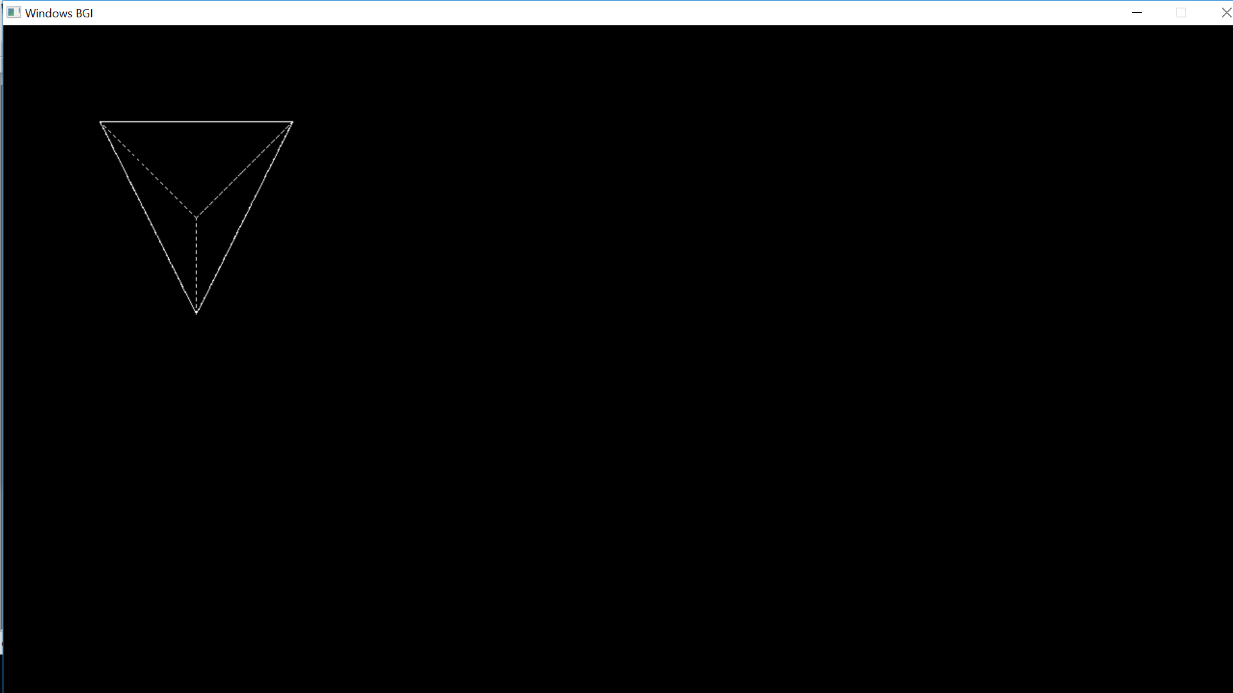

1. **Drawing our name using hermite curve**

#include <iostream>

#include <graphics.h>

#include <cstdio>

using namespace std;

struct point

{

int x,y;

};

void curve ( point p0, point p1, float rx0, float ry0, float rx1, float ry1)

{

float x,y,t;

for ( t = 0 ; t <= 1.0 ; t = t + 0.01 )

{

x = ( 2*t*t*t - 3*t*t + 1 )*p0.x + (-1*2*t*t*t + 3*t*t)*p1.x + ( t*t*t - 2*t*t + t)*rx0 + ( t*t*t - t*t )*rx1;

y = ( 2*t*t*t - 3*t*t + 1 )*p0.y + (-1*2*t*t*t + 3*t*t)*p1.y + ( t*t*t - 2*t*t + t)*ry0 + ( t*t*t - t*t )*ry1;

putpixel(x,y,WHITE);

}

}

int main()

{

int gd=DETECT,gm;

initgraph(&gd,&gm,"..//BGI");

point p0,p1;

p0.x = 100;

p0.y = 100;

p1.x = 90;

p1.y = 125;

curve(p0,p1,100,0,5,0);

p0.x = 90;

p0.y = 125;

p1.x = 130;

p1.y = 125;

curve(p0,p1,100,0,20,-20*1.73);

p0.x = 130;

p0.y = 100;

p1.x = 130;

p1.y = 150;

curve(p0,p1,5,0,5,0);

p0.x = 150;

p0.y = 100;

p1.x = 150;

p1.y = 125;

curve(p0,p1,100,0,5,0);

p0.x = 150;

p0.y = 100;

p1.x = 150;

p1.y = 110;

curve(p0,p1,20,0,20,0);

p0.x = 150;

p0.y = 110;

p1.x = 150;

p1.y = 100;

curve(p0,p1,10,0,-10,0);

p0.x = 150;

p0.y = 125;

p1.x = 170;

p1.y = 150;

curve(p0,p1,-10,0,5,50);

p0.x = 180;

p0.y = 100;

p1.x = 180;

p1.y = 150;

curve(p0,p1,0,5,0,5);

p0.x = 90;

p0.y = 100;

p1.x = 190;

p1.y = 100;

curve(p0,p1,5,0,5,0);

getch();

closegraph();

return 0;

}

**OUTPUT:**

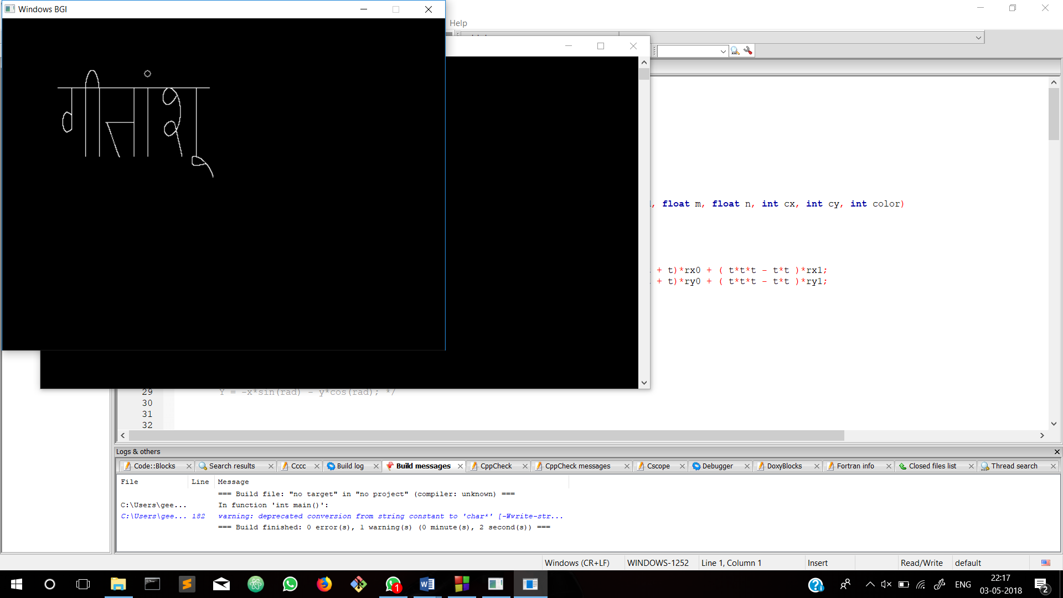

1. **Demonstrating the dimetric view of a cube**

#include<iostream>

#include<bits/stdc++.h>

#include<graphics.h>

#include<conio.h>

#include<dos.h>

#include<math.h>

#include <stdlib.h>

#include <stdio.h>

using namespace std;

float ob[4][8]={

0 ,40,40,0 ,0 ,40,40,0,

0 ,0 ,40,40,0 ,0 ,40,40,

0 ,0 ,0 ,0 ,40,40,40,40,

1,1,1,1,1,1,1,1

};

float t,pi=3.14;

float ob1[4][8],ob2[4][8];

float roty[4][4]=

{cos(pi/180),0,sin(pi/180),0,

0,1,0,0,

-sin(pi/180),0,cos(pi/180),0,

0,0,0,1

};

float rotx[4][4]=

{1 ,0,0,0,

0,cos(pi/180),-sin(pi/180),0,

0,sin(pi/180),cos(pi/180),0,

0,0,0,1

};

float rotz[4][4]=

{cos(pi/180),-sin(pi/180),0,0,

sin(pi/180),cos(pi/180),0,0,

0,0,1,0,

0,0,0,1};

float isometric[4][4]={0.7071,0,-0.7071,0,-0.40825,0.8165,-0.40825,0,0.7071,0.40825,0.8165,0,0,0,0,1};

//matmul(isometric,ob1);

void matmul(float mat1[4][4],float mat2[4][8])

{

float res[4][8];

int i,j,k;

for(i=0;i<4;i++)

{

for(j=0;j<8;j++)

{

res[i][j]=0;

for(k=0;k<4;k++)

{

res[i][j]+=mat1[i][k]*mat2[k][j];

}

}

}

for(int i=0;i<4;i++){

for(int j=0;j<8;j++)

mat2[i][j]=res[i][j];

}

}

void diview(float ob[4][8])

{

int i=0;

for(i=0;i<4;i++)

line(219+ob[0][i%4],300-ob[1][i%4],219+ob[0][(i+1)%4],300-ob[1][(i+1)%4]);

for(i=4;i<8;i++)

line(219+ob[0][i%4+4],300-ob[1][i%4+4],219+ob[0][(i+1)%4+4],300-ob[1][(i+1)%4+4]);

for(i=0;i<4;i++)

line(219+ob[0][(i%8)],300-ob[1][i%8],219+ob[0][(i+4)%8],300-ob[1][(i+4)%8]);

}

//float dimetric[4][4];

void rot(float ob[4][8],float ob1[4][8],float ob2[4][8],float dimetric[4][4])

{

float t;

float obnew[4][8];

int i,j,k;

matmul(isometric,ob1);

matmul(dimetric,ob2);

for(t=0;t<=10;t+=0.01)

{

matmul(roty,ob);

matmul(rotx,ob1);

matmul(rotx,ob2);

setcolor(WHITE);

diview(ob2);

delay(20);

cleardevice();

}

}

int main()

{

int gdrive=DETECT,gmode;

for(int i=0;i<4;i++)

{

for(int j=0;j<8;j++)

{

ob1[i][j]=ob2[i][j]=ob[i][j];

}

}

float th1,th2,k;

cout<<"enter k";

cin>>k;

//th1=asin(sqrt(k*k/2)),th2=asin(sqrt(k*k/(k*k+2)));

//th1=acos(sqrt(1/2)),th2=acos(sqrt(2*k*k/(k*k+2)));

//th1=asin(sqrt(1/2)),th2=asin(-sqrt((2-k*k)/(2*(1+k*k))));

th1=acos(sqrt(k*k/2)),th2=acos(sqrt(2/(k*k+2)));

float dimetric[4][4]={cos(th1),0,-sin(th1),0,-sin(th1)*sin(th2),cos(th2),-sin(th2)*cos(th1),0,cos(th2)*sin(th1),sin(th2),cos(th2)*cos(th1),0,0,0,0,1};

//float x=x1,R=50,y=y1,d;

initgraph(&gdrive,&gmode,"C:\\TURBOC3\\BGI");

/*matmul(dimetric,ob2);

frontview(ob2);

diview(ob2);

matmul(isometric,ob1);

isoview(ob1);*/

rot(ob,ob1,ob2,dimetric);

//isomet(ob1,isometric);

getche();

return 0;

}

**OUTPUT:**

